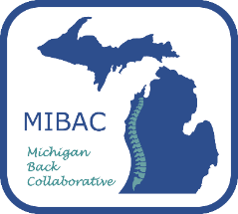
Quality Improvement Information for Chiropractors (who completed training in 2021)

What do I need to do to participate in MIBAC Quality Improvement (L3)?
- Review information about the MIBAC program and participation in Quality Improvement
- If you are interested in participating and are in a PO, contact your PO leader
- If you are interested in participating and are not in a PO, please use the link or QR code below to complete a letter of interest, or visit mibac.org>members to complete
June 1, 2022-July 15, 2022
- Participation agreements are due July 15, 2022, and will be sent to the interested practitioner after the letter of interest is complete
June 1, 2022 – October 1, 2022
- Enroll in Patient Reported Outcome (PRO) platform thru PatientIQ
- The enrollment form is available on mibac.org > PROs > MIBAC / PatientIQ Registration (enrollment is free-of-charge to participants), or you can use the QR code below
October 1, 2022+
- Select appropriate patients for enrollment in the MIBAC program
- Enroll patients in the PatientIQ PRO platform within 2 days of first visit for back pain
- Complete clinical form after first visit, within 5 business days
- Enroll a minimum of 10 patients within the calendar year
VBR is prospective and participation based. The 5% VBR payments will begin Sept 1, 2022 and will renew Sept 1, 2023 if participation requirements have been met
If you would like more detailed information, email dwalker3@hfhs.org

